

FM Wholesale ERP
User Guide
How to run FM Shoes on the system - from ordering stock overseas to collecting the money

Demo version | October 2026
Contents
1. Start here - the system in one page 4
The business cycle 4
2. Logging in and finding your way 5
Logging in 5
The dashboard 5
3. One-time setup (before the first day) 7
3.1 Company and pricing rules 7
3.2 Brands, categories and stores 7
3.3 Products 7
3.4 Customer groups and price lists 7
3.5 Customers 8
3.6 Suppliers 8
3.7 Cash and bank accounts 8
3.8 Opening stock 8
3.9 Users 8
4. Buying and importing stock 9
Step 1 - Create the purchase order 9
Step 2 - Import costing 10
Step 3 - Receive the goods (GRN) 11
What the system does when you post the GRN 12
Step 4 - Update selling prices 12
5. Selling 13
5.1 Create an invoice 13
5.2 The invoice page 14
5.3 Delivering in parts 14
5.4 Quotations and sales orders (optional) 15
5.5 Returns and credit notes 15
6. Money: receipts, cheques and payments 16
6.1 Receive payment from a customer 16
6.2 Cheques 16
6.3 Pay a supplier 17
6.4 Expenses 17
6.5 Daily cashbook and bank balances 18
7. Credit control - getting paid on time 19
8. Looking after stock 20
8.1 Stock on hand 20
8.2 Other stock tasks 20
9. Reports - which report answers which question 21
10. Daily, weekly and monthly routine 22
Every day 22
Every week 22
Every month 22
11. Using the system on a phone 23
12. Common questions 24
13. Quick reference card 25
Notes about this demo version 25

1. Start here - the system in one page
The system has many screens, but you do not need to learn them all. FM Shoes does the same few things every day: buy stock, sell stock, collect money and check the numbers. Every screen belongs to one of these steps.
Most of the daily work uses only four buttons - they are always at the top of every page:
- New Invoice - sell to a customer
- Receive Payment - record money from a customer (cash, bank transfer, card or cheque)
- New PO - order stock from a supplier
- The bell - shows what needs attention today (overdue customers, cheques to deposit, low stock)

The business cycle
This is the whole business, start to end. Follow the steps in this order:
# | What happens in the business | Where in the system | Who usually does it
1 | Order shoes from an overseas supplier | Import & Purchasing > New Purchase Order | Owner / Manager
2 | Add freight, insurance, duty and clearing costs | Purchase Order > Import costing | Manager / Accounts
3 | Container arrives - count the cartons | Purchase Order > Receive goods (GRN) | Store
4 | Set selling prices from the new cost | Pricing > Bulk Price Update | Manager
5 | Sell to a shop (cash or credit) | New Invoice | Sales
6 | Send the goods (all now, or in parts) | Invoice > Deliver | Store
7 | Collect money and cheques | Receive Payment, Payments > Cheques | Accounts
8 | Pay the supplier | Payments > Supplier Payments | Accounts
9 | Follow up late payers | Credit Control > Overdue & Reminders | Accounts / Owner
10 | Check how the business is doing | Dashboard, Reports | Owner

Tip
New staff should learn only the steps for their role. A sales person needs steps 5 and 7. The store needs steps 3 and 6. Accounts need steps 7, 8 and 9.

2. Logging in and finding your way

Logging in
Open the system in a browser (Chrome is recommended) on a computer or a phone. Enter your email address and password, then click Sign In.
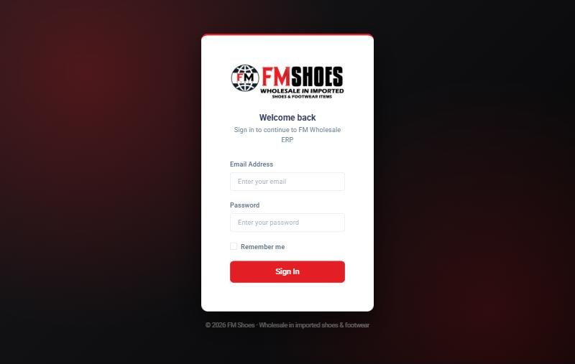
The login screen
Each person gets their own login. What you can do depends on your role:
Role | Can do
Super Admin / Manager | Everything. Can override price limits, discount limits and credit blocks. Manages settings and users.
Sales | Quotations, invoices and receipts. Must stay within the discount limit and minimum price.
Store | Goods received (GRN), deliveries, stock transfers, damaged stock and stock counts.
Accounts | Receipts, supplier payments, cheques, expenses and reports.

The dashboard
After logging in you see the dashboard - a summary of the business today.
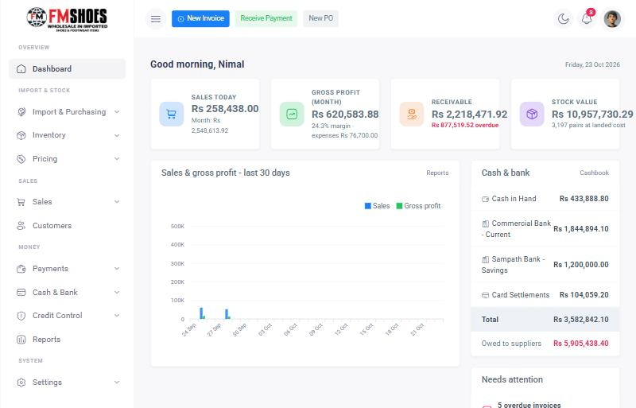
The dashboard: sales today, profit, money owed to you, stock value and bank balances
- Left menu - all screens, grouped by job (Import & Stock, Sales, Money, Reports, Settings). Click the three-line button at the top to hide or show it.
- Top buttons - New Invoice, Receive Payment and New PO, from any page.
- Bell - alerts. The red number shows how many things need attention.
- Moon icon - switch between light and dark screen.
- Your photo - your profile and Logout.
Tip
Every number on the dashboard can be clicked to see the details behind it.

3. One-time setup (before the first day)
Do these steps once, in this order. After that the system is ready for daily work. A manager should do the setup.

3.1 Company and pricing rules
Where: Settings > Company & Pricing Rules
- Company name, address and phone - printed on every invoice.
- Default markup % - how much to add on top of the landed cost to get the selling price (for example 35%).
- Minimum margin % - the lowest profit allowed. Sales staff cannot sell below cost plus this %.
- Maximum discount % - the most discount a sales person can give. Managers can give more.
- Default credit days - normal payment time for new customers (for example 30 days).

3.2 Brands, categories and stores
Where: Settings > Brands, Categories & Stores
Add your brands, product categories (for example Men's Casual, Ladies Sandals, Kids Shoes) and your stores or warehouses. Each category can have its own markup % - for example slippers 50%, sports shoes 30%.

3.3 Products
Where: Inventory > Products > New Product (or Inventory > Bulk Import for many products)
One product = one model in one colour. For example "Walkmaxx Canvas Loafer - Navy". For each product enter:
- Product code - your article number, for example WM-1021.
- Size run - for example 39-44. The system creates a separate stock item (SKU) for every size, so stock is always tracked per size.
- Pairs per carton - for example 12. Used for the "Quick fill" carton button.
- Wholesale price, minimum price and re-order level - the re-order level is the number of pairs at which the system warns you to re-order.
Tip
Many products? Use Inventory > Bulk Import (Excel/CSV). Download the template, fill it in Excel, save it as "CSV (Comma delimited)" and upload it.

3.4 Customer groups and price lists
Where: Pricing > Customer Groups & Price Lists
Customer groups are price levels. For example:
- Key Accounts - 7% below the wholesale price
- Standard Wholesale - the normal wholesale price
- Small Retailers - 5% above the wholesale price
You can also set a special fixed price for one product for one group (click Price list). When you make an invoice, the price is filled in automatically from the customer's group.

3.5 Customers
Where: Customers > New Customer
Enter the shop name, phone, WhatsApp number, city, customer group, credit limit and payment terms (days). The credit limit protects you: the system will not allow a credit sale that takes the customer over the limit.

3.6 Suppliers
Where: Import & Purchasing > Suppliers
Enter the supplier name, country, the currency they invoice in (usually USD) and payment terms.

3.7 Cash and bank accounts
Where: Cash & Bank > Accounts & Balances > New account
Add Cash in Hand, each bank account and a Card Settlements account. Enter the opening balance of each one on the day you start.

3.8 Opening stock
To load the stock you already have, with its correct cost:
- Create a supplier called "Opening Stock" with currency LKR.
- Make a Purchase Order from this supplier with exchange rate 1. Enter each product's pairs per size and its current cost per pair as the unit price.
- Click Receive goods (GRN) and post it. The stock and cost are now in the system.

3.9 Users
Where: Settings > Users & Roles
Add a login for each staff member and choose their role. Ask everyone to change their password the first time they log in (click your photo > My Account).

4. Buying and importing stock
This is the most important part of FM Shoes, because the real cost of imported shoes is more than the supplier's price. Freight, insurance, customs duty and clearing charges must be added. The system does this automatically and shares the charges across all the shoes in the shipment.
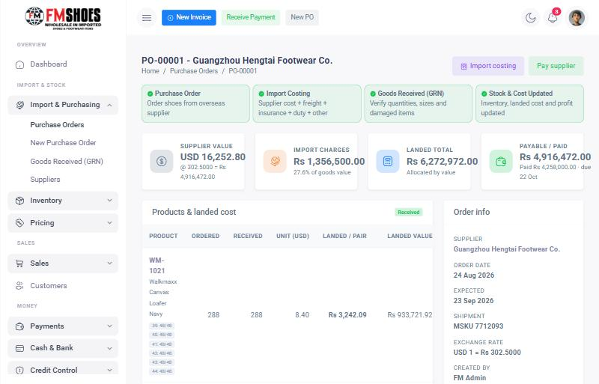
Every purchase order shows its progress: Purchase Order > Import Costing > Goods Received > Stock & Cost Updated

Step 1 - Create the purchase order
Where: New PO (top button) or Import & Purchasing > New Purchase Order
- Choose the supplier. Enter the order date, expected arrival date, currency and today's exchange rate.
- Enter the container or shipment number if you have it.
- In "Search product", type a code or name and press Enter to add the product.
- Enter the unit price in the supplier's currency (USD).
- Enter the pairs for each size. Or type the number of cartons in Quick fill and click Fill - the pairs are spread evenly across all sizes.
- Repeat for each product, then click "Save & mark ordered". (Use "Save draft" if you are not ready to send it.)
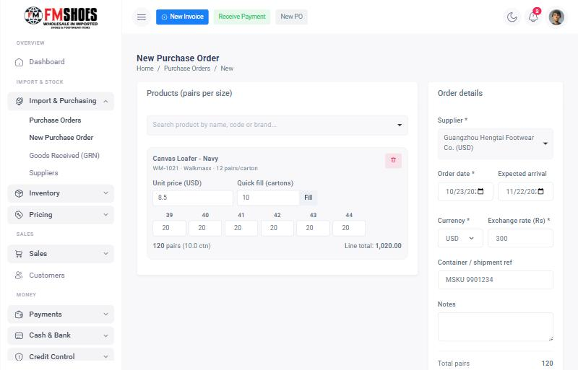
New purchase order: 10 cartons spread across sizes 39-44 with Quick fill

Step 2 - Import costing
Where: Open the purchase order > Import costing
When you know the shipping and customs costs, enter them here. You can come back and change them any time until the goods are received.
- Check the exchange rate (use the rate you actually paid).
- Enter each charge in rupees: Freight, Insurance, Customs duty, Clearing & port charges, Local transport, Other.
- Choose how to share the charges: by Value (expensive shoes take a bigger share - recommended) or by Quantity (every pair takes the same share).
- Click "Save & recalculate".
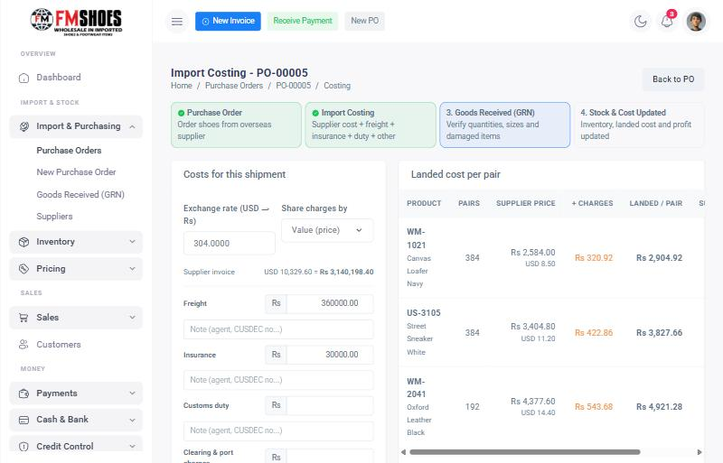
Import costing: supplier price + share of charges = landed cost per pair
Read the table on the right: for each product you can see the supplier price in rupees, the extra charges per pair (orange), the landed cost per pair (the real cost) and a suggested selling price.

Step 3 - Receive the goods (GRN)
Where: Open the purchase order > Receive goods (GRN)
When the container arrives, the store counts the goods and records what really came.
- Click "Receive goods (GRN)", choose the store and the date, then click Start GRN. All ordered quantities are filled in.
- Count each carton. Change the Received number for any size where fewer pairs arrived.
- Enter any damaged pairs in the Damaged row. Damaged pairs are kept apart and cannot be sold.
- Click "Save draft" if you are still counting, or "Post GRN & update stock" when the count is finished.
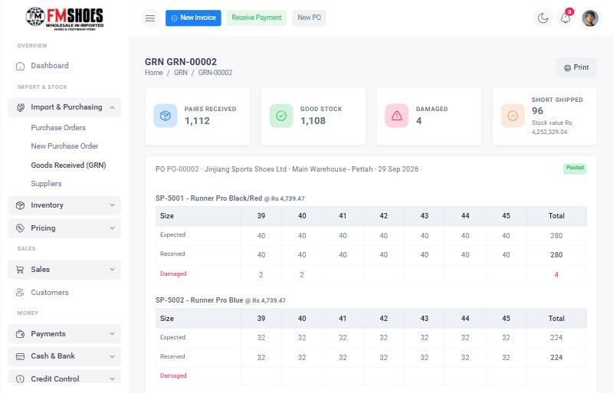
A posted GRN: received, good stock, damaged and short-shipped pairs per size
Important
After a GRN is posted it cannot be changed. Check the count before posting. If not everything arrived, post what arrived - the PO shows "Partly received" and you can make a second GRN later for the rest.

What the system does when you post the GRN
- Good pairs are added to stock, size by size.
- The product cost is updated to the new average landed cost (old stock and new stock are averaged).
- The amount you owe the supplier is recorded, with a due date based on the supplier's payment terms.

Step 4 - Update selling prices
Where: Pricing > Bulk Price Update
After a new shipment, the cost may have changed. Choose a brand or category, choose "Landed cost + markup %", click Preview, check the new prices and margins, then click Apply new prices.

5. Selling

5.1 Create an invoice
Where: New Invoice (top button)
- Choose the customer. Their group, balance, credit limit and any overdue amount are shown under the name.
- Search and add the products. The price is filled in from the customer's group. Stock is shown under every size.
- Enter pairs per size, or use Quick fill for whole cartons. Add a discount % if needed.
- Credit sale - the customer pays later (due date = invoice date + their credit days). Cash sale - must be paid in full now.
- Leave "Deliver all items now" on if the goods leave with the customer. Turn it off to deliver later.
- If money is received now, turn on Paid now and enter the payment. To split (for example part cash, part card), click "Add another method".
- Click Save invoice.
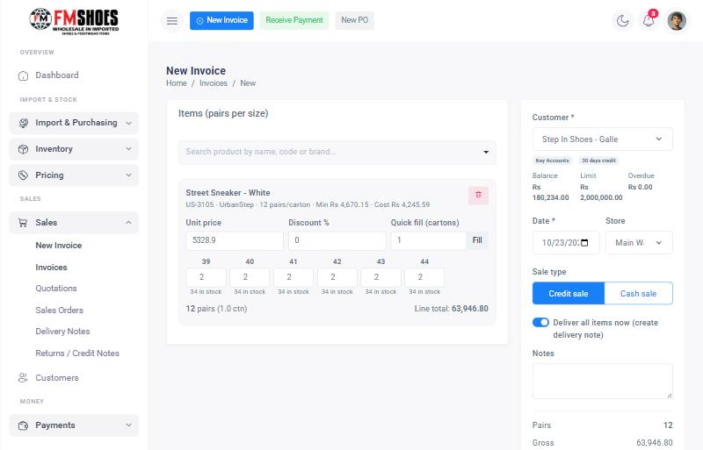
New invoice: group price filled in automatically, stock shown per size, credit details of the customer on the right
Important
The system protects your profit and your money. These rules apply to Sales users:
- The price after discount cannot be below the product's minimum selling price.
- The discount cannot be more than the maximum discount in Settings.
- A credit sale is blocked if it takes the customer over their credit limit, or if they have overdue invoices.
A Manager can tick "Manager override" on the invoice to allow it.

5.2 The invoice page
After saving, the invoice page shows the total, balance due, profit and delivery status. From here you can:
- Print - print the invoice or save it as PDF.
- Deliver - send all or part of the goods.
- Receive payment - record money for this invoice.
- Return / credit note - when the customer returns shoes.
- WhatsApp button - send the invoice details to the customer's WhatsApp.
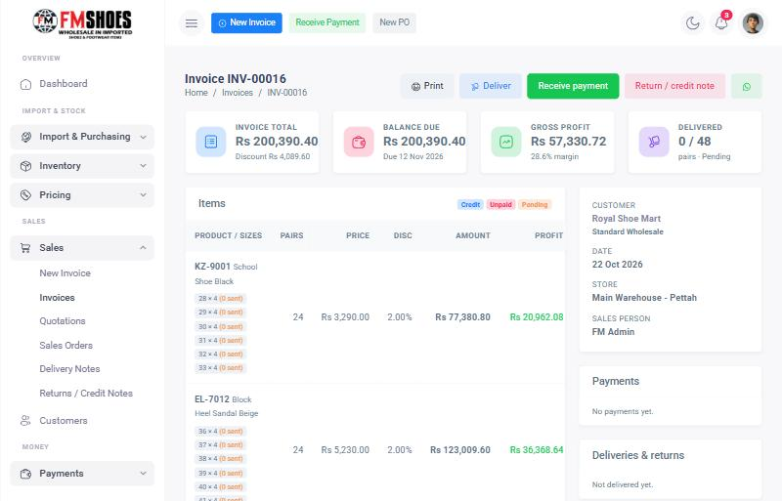
Invoice page with totals, profit, payment and delivery status

5.3 Delivering in parts
Where: Invoice > Deliver
Enter the pairs going out now for each size (or click "Fill all"), the vehicle number and who received the goods, then click Create delivery note. Stock is reduced only for what is delivered. The rest stays on the invoice for a later delivery.
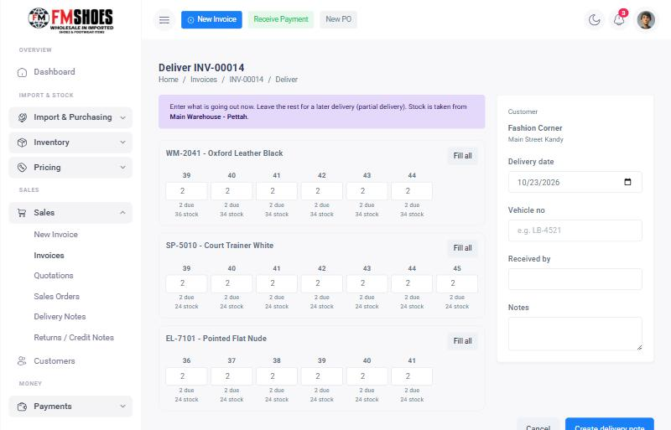
Delivery note: pairs still due and stock available are shown under each size

5.4 Quotations and sales orders (optional)
Where: Sales > Quotations or Sales > Sales Orders
Use a quotation when a customer asks for prices first. When they agree, open it and click "Convert to sales order" or "Create invoice". Nothing is taken from stock until the invoice is delivered.

5.5 Returns and credit notes
Where: Invoice > Return / credit note
Enter the pairs returned per size and the reason. Leave "Goods came back - add to stock" ticked to put the shoes back in stock. Untick it for a price adjustment only. The credit note reduces what the customer owes.

6. Money: receipts, cheques and payments

6.1 Receive payment from a customer
Where: Receive Payment (top button)
- Choose the customer. Their unpaid invoices are listed on the right.
- Enter the payment: method (cash, bank transfer, card or cheque), amount and account.
- For a cheque, enter the cheque number, bank and cheque date. Post-dated cheques are fine - enter the date written on the cheque.
- If the customer pays in more than one way, click "Add another method".
- Leave Oldest first on to apply the money to the oldest invoices automatically, or type the amount for each invoice yourself.
- Click Save receipt. A printable receipt opens.
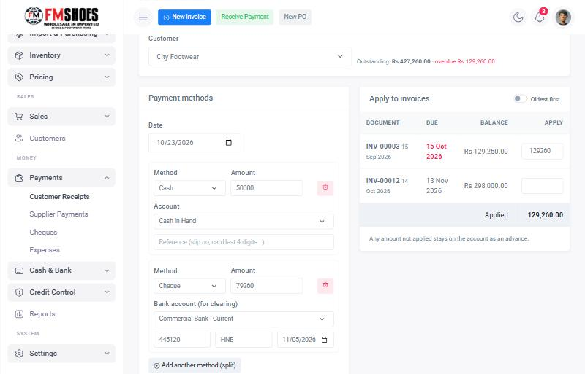
One receipt split into cash and a post-dated cheque, applied to the oldest invoice first
Tip
Money that is not applied to an invoice stays on the customer's account as an advance and reduces their balance.

6.2 Cheques
Where: Payments > Cheques
Every cheque received from customers (and issued to suppliers) is listed with its date and status. Post-dated cheques show how many days are left.
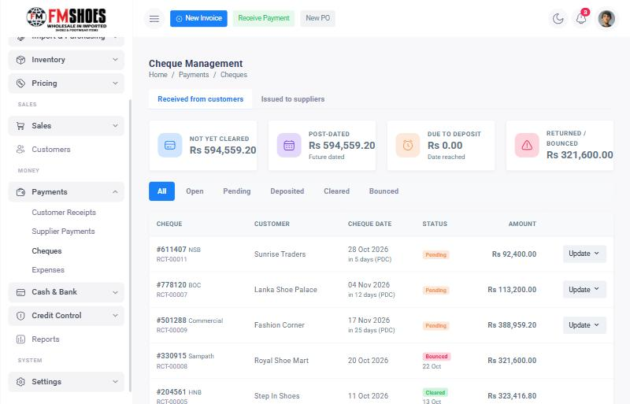
Cheque list with post-dated, due and returned totals
Click Update on a cheque to change its status:
Status | Meaning | What the system does
Pending | You have the cheque, not yet banked | Nothing yet. Shown in alerts when the date comes near.
Deposited | Banked, waiting for clearance | Nothing yet.
Cleared | The money is in the bank | Adds the amount to the bank account.
Bounced | The cheque was returned | Puts the amount back on the customer's balance and re-opens the invoice.

6.3 Pay a supplier
Where: Payments > Supplier Payments > Pay Supplier
Choose the supplier, enter the payment (bank transfer / TT, cash or a cheque you issue) and apply it to their purchase orders. Issued cheques are tracked in Payments > Cheques > Issued to suppliers, so you know how much must be in the bank on each date.

6.4 Expenses
Where: Payments > Expenses > New Expense
Record rent, salaries, electricity, transport and other costs. Choose the category and the account it was paid from. Expenses are deducted in the profit report.

6.5 Daily cashbook and bank balances
Where: Cash & Bank > Daily Cashbook
Shows, for any day, the opening balance, money in, money out and closing balance of every account, with each transaction listed. Use Prev / Next to move between days. To record cash banked, use Cash & Bank > Accounts & Balances > Transfer / deposit.
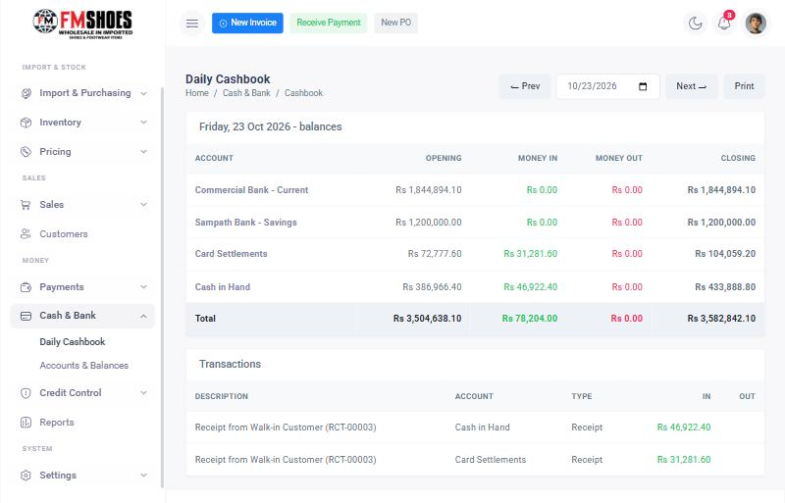
Daily cashbook

7. Credit control - getting paid on time
Where: Credit Control > Overdue & Reminders
Check this page every morning. It shows:
- All overdue invoices, with how many days late they are.
- Invoices coming due in the next few days - send a friendly reminder before they become late.
- Every customer's credit limit and how much of it is used.
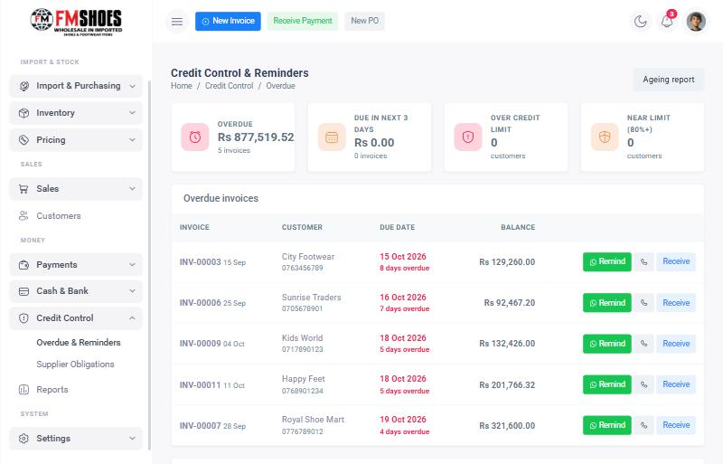
Overdue invoices with one-click reminder, call and receive buttons
Remind opens WhatsApp with a ready-made polite message showing the invoice number, amount and days overdue. Just press send. Receive opens the receipt screen for that invoice.
Supplier obligations (Credit Control > Supplier Obligations) shows what you must pay suppliers, by due date, and the cheques you issued that are coming due.

8. Looking after stock

8.1 Stock on hand
Where: Inventory > Stock on Hand
Every product with its stock per size, total pairs, cartons and value. Red means a size is sold out. Filter by store, brand or "Low stock".
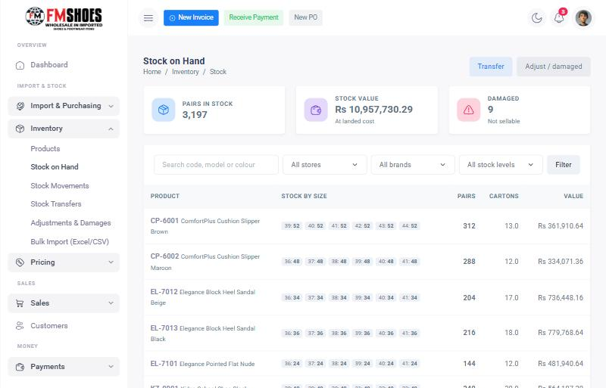
Stock on hand by size

8.2 Other stock tasks
I want to... | Go to | Notes
Move stock to the showroom | Inventory > Stock Transfers > New Transfer | Choose From and To store, enter pairs per size.
Mark shoes as damaged | Inventory > Adjustments & Damages | Reason "Mark as damaged". They stop being sellable.
Throw away damaged shoes | Inventory > Adjustments & Damages | Reason "Write off damaged".
Correct stock after a count | Inventory > Adjustments & Damages | Reason "Stock count correction", then choose add or remove.
Send shoes back to a supplier | Inventory > Adjustments & Damages | Reason "Return to supplier".
See every stock movement | Inventory > Stock Movements | Each in and out with date, document and user.
See what to re-order | Reports > Low stock & missing sizes | Products below re-order level and sold-out sizes.

9. Reports - which report answers which question
Where: Reports
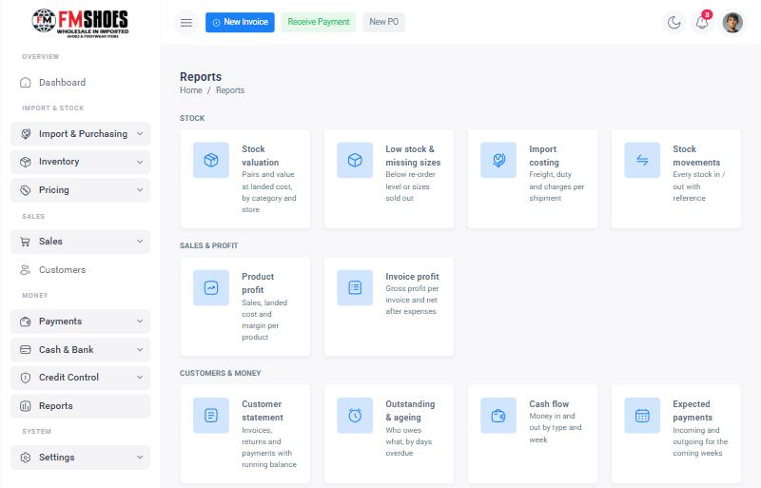
All reports in one place
Question | Report
How much stock do I have and what is it worth? | Stock valuation
What do I need to re-order? | Low stock & missing sizes
What did each shipment really cost? | Import costing
Which products make the most profit? | Product profit
How much profit did I make this month, after expenses? | Invoice profit
What does this customer owe, and what did they pay? | Customer statement (can also be sent by WhatsApp)
Who owes me money, and how late are they? | Outstanding & ageing
Where did the money come from and go? | Cash flow
Will I have enough money in the coming weeks? | Expected payments
What happened in cash and bank today? | Daily cashbook

Tip
Every report has a Print button. In the print window choose "Save as PDF" to email it.

10. Daily, weekly and monthly routine

Every day
Who | What to do
Owner / Manager | Look at the dashboard and the bell. Approve any credit overrides.
Sales | Make invoices. Record payments received from customers.
Store | Deliver pending invoices (Sales > Invoices, filter "Pending delivery"). Record GRNs when goods arrive.
Accounts | Check Credit Control and send reminders. Deposit cheques that are due. Mark cheques cleared or bounced. Check the Daily Cashbook against the cash in the drawer.

Every week
- Check Supplier Obligations - plan supplier payments and issued cheques.
- Check Low stock & missing sizes - plan the next order.
- Check Expected payments - make sure the bank has enough money.

Every month
- Invoice profit report - profit after expenses.
- Outstanding & ageing - follow up anyone more than 30 days late. Consider lowering their credit limit.
- Stock count of a few products and correct with Adjustments.
- After each new shipment, run Bulk Price Update.

11. Using the system on a phone
Everything works on a phone in the browser. Lists become cards that are easy to read, and the Save buttons stay at the bottom of the screen.
- Tap the round + button at the top for New Invoice, New Quotation, Receive Payment, New Purchase Order or New Expense.
- Tap the three-line button to open the menu.
- Tip: in Chrome, choose "Add to Home screen" to open the system like an app.
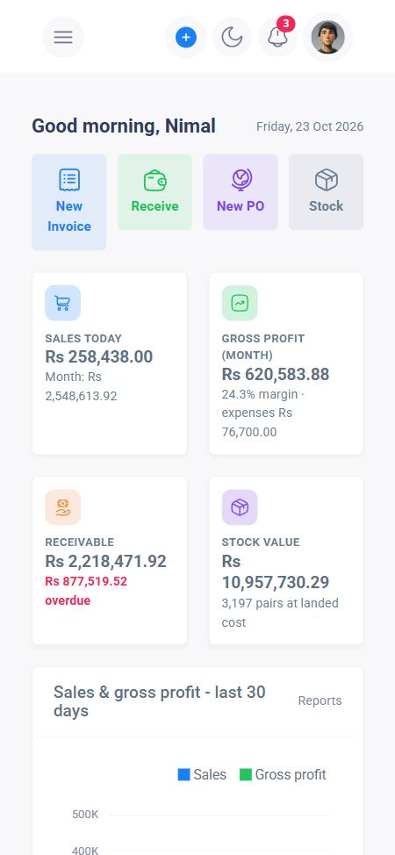  Dashboard on a phone | 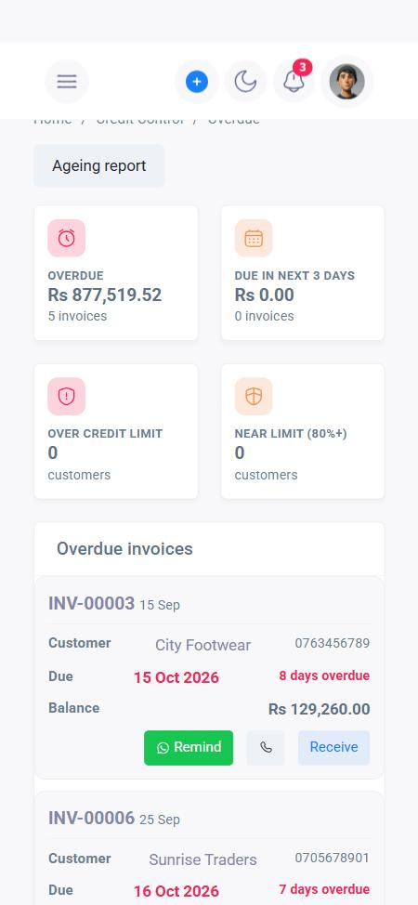  Credit control on a phone

12. Common questions
Problem | What to do
"Not enough stock" when saving an invoice | Check the store selected on the invoice and the stock under each size. Reduce the quantity, transfer stock from the other store, or turn off "Deliver all items now" and deliver later.
"Credit limit exceeded" or "has overdue invoices" | Collect payment first, or ask a Manager to tick "Manager override".
"Price is below the minimum selling price" | Increase the price or reduce the discount. A Manager can override.
I made a mistake on a posted GRN | Posted documents cannot be edited. Use Inventory > Adjustments & Damages to correct the stock.
I made a mistake on an invoice | Use Return / credit note on the invoice, then make a new invoice.
A customer's cheque bounced | Payments > Cheques > Update > Bounced. The amount goes back on the customer's balance automatically.
The cost of a product looks wrong | Check the import costing of its last purchase order (exchange rate and charges). Costing can be changed only before the GRN is posted.
I forgot my password | Ask a Manager to set a new one in Settings > Users & Roles.

13. Quick reference card
Print this page and keep it next to the computer.
I want to... | Click
Sell to a customer | New Invoice
Give a price quote | Sales > Quotations > New Quotation
Record money from a customer | Receive Payment
Bank or clear a cheque | Payments > Cheques > Update
Order from a supplier | New PO
Add shipping and duty costs | Purchase Order > Import costing
Receive a container | Purchase Order > Receive goods (GRN)
Deliver goods to a customer | Invoice > Deliver
Take back returned shoes | Invoice > Return / credit note
Pay a supplier | Payments > Supplier Payments
Record an expense | Payments > Expenses > New Expense
Remind a late payer | Credit Control > Remind
See stock by size | Inventory > Stock on Hand
Change selling prices | Pricing > Bulk Price Update
See today's cash and bank | Cash & Bank > Daily Cashbook
See profit | Reports > Invoice profit / Product profit

Notes about this demo version
The demo uses these settings. They can be changed after discussion with FM Shoes:
- Home currency is Sri Lankan Rupees (Rs). Suppliers invoice in USD, with the exchange rate entered for each shipment.
- Stock is counted in pairs. A carton has a fixed number of pairs, spread evenly across the sizes.
- Cost is the weighted average landed cost. Import charges are shared by value unless changed on the shipment.
- Two stores: Main Warehouse and Showroom. No VAT on invoices yet.
- Customer reminders are sent with WhatsApp. Bulk import uses CSV files saved from Excel.

